

**UGANDA MUSLIM TEACHERS’ ASSOCIATION**

**UMTA JOINT MOCK EXAMINATIONS 2014**

**P640/1**

**FOODS & NUTRITION**

**(With science in the home)**

**Paper 1**

**3 hours**

**UGANDA ADVANCED CERTIFICATE OF EDUCATION**

**FOODS AND NUTRITION**

**(With science in the Home)**

**(Theory)**

**INSTRUCTIONS TO CANDIDATES**

Attempt four questions, only two from each section

**SECTION A**

1. 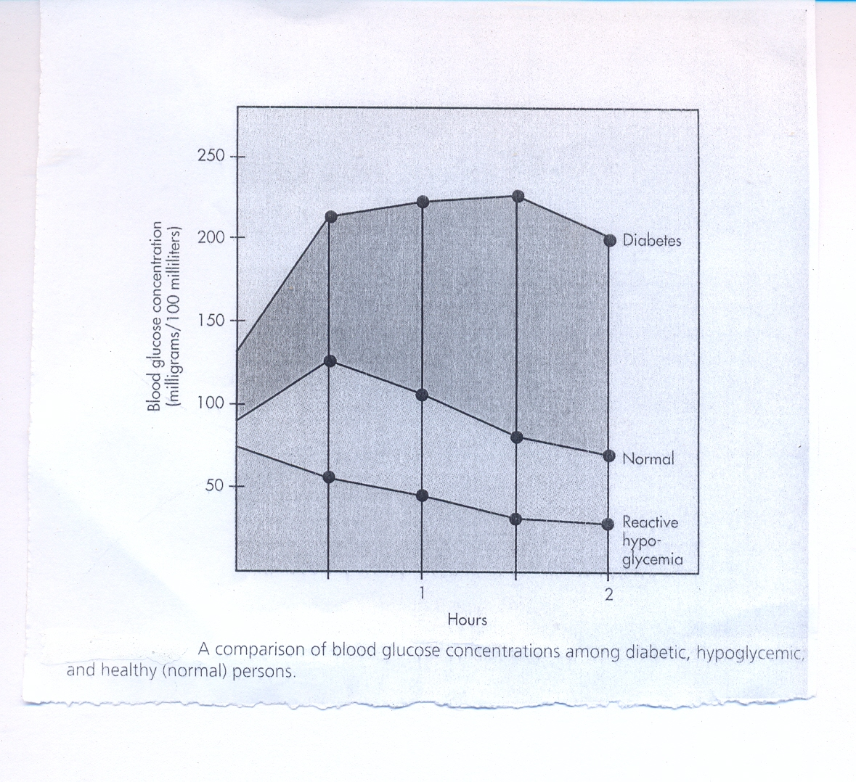**A graph showing a comparison of blood glucose concentrations among diabetic, hypoglycemic, and healthy (normal) persons.**
2. Compare the blood glucose levels in the three categories of people ( 6marks)

* The blood levels are high with the diabetic patient compared to those of the Normal and reactive hypoglycemic.
* In the normal,the glucose levels are slightly higher than those with reactive hypoglcemia
* In the Reactive hypoglycaemia,the glucose levels are the lowest in all the three categories

1. Account for the following;
2. The initial rapid increase in the glucose level of a diabetic person (3 marks)

* The patient had just finished taking a meal and the glucose levels were slightly higher after digestion.
* And because insulin is ineffective or less efficient,the glucose levels kept piling up in all situations

1. The final gradual decrease in glucose levels of a diabetic person (3marks )

* The individual has stopped feeding and so the glucose levels were initially high,then constant and finally declining.The decrease is because the little effective glucose has started to slowly break down the glucose present.

1. Explain the gradual decrease of blood glucose levels
2. In a normal person after half an hour (2 marks)

(i) This person has the right amount of insulin to break down the glucose so its because the glucose has been metabolized to other forms like glycogen in the body. And the decrease continues because further metabolism is taking place.

1. In a reactive hypoglycemic person from the start of the experiment ( 3marks)

This individual has high amounts of insulin in the body, so all the glucose metabolized quickly and faster because of the high amounts of insulin present. So they is quick metabolism of glucose to their corresponding metabolites.

1. (i) Explain the other type of hypoglycemia ( 2 marks)

hypoglycemia- is characterized by chronically low blood glucose levels because the pancreas constantly produces too much insulin.

This occurs whether or not there has been a surge of glucose into the blood to stimulate excessive insulin production.

(ii) Discuss the different types of diabetics that occur in people (4 marks)

* Type 1 Diabetes (I DDM)

It’s the type of diabetes in which the person does not secrete enough insulin.

Prevalence is 5-10%

Develops suddenly and is more severe and unstable, It's also called Juvenile- on set diabetes.

* Type ii Diabetes (NIDDM)

Prevalence is 80-95%

Develops more slowly and is usually milder and more stable.

- It is called Adult / maturity on-set Diabetes because it develops later in life, after 40 years.

- These diabetics don't have an insulin deficiency, rather they have a normal amount but their insulin is ineffective in removing the glucose from the blood into the cells.

- Diabetic insipidus- involves +

iii) State the complications related to diabetes patients.

* Hyperglycemia- Blood glucose level rises too high.
* Glucosuria ( Appearance of glucose in the urine)
* Polyuria ( thirst)
* Polydipsia ( feeling of hunger)
* Weight loss due to muscle protein being broken down.
* Fatigue / tiredness
* Dehydration due to increased urination leading to shock, coma and finally death.
* Loose dry skin, dry tongue with cracked lips.
* Pain n legs ; depression of ankle jacks and impaired vibrational sense.
* Failing vision / blurred vision ( reduction in visual acuity).
* Infections especially pulmonary TB and urinary tract infections.
* Skin itching, around external genitalia.

2(a) Fibrinogen is a plasma protein which is important in the clotting of blood”.

How is fibrinogen manufactured in the body? (6 marks)

Fibrinogen is a plasma protein which is important in the clotting of blood.How is fibrinogen manufactured in the body?

This takes place through synthesis in the cells. The amino acids necessary for formation of fibrinogen are taken into the cells from the general blood circulation and are strung together in patterns which are detected by DNA from the cell nucleus. This is called polypeptide cell formation and occurs on the ribosomes in the cytoplasm. This takes place as follows:

* *Information in form of codons from the DNA is carried from the nucleus to the ribosome by messenger ribonucleic acid (mRNA). This is called transcription.*
* *Waiting in the cytoplasm are small molecules of transfer ribonucleic acid (tRNA). Each tRNA contains a single 3-nucleotide sequence called anticodons that fits a similar sequence on the mRNA strands.*
* *Each tRNA collects appropriate amino acids necessary for fibrinogen formation from the amino acid pool in the cytoplasm. This amino acid pool is from the digested protein or breaking down of the existing proteins.*
* *The tRNA then takes the amino acids to the ribosome where they link up to form polyeptide chains of fibrinogen*
* *polyeptide chains of fibrinogen.*

**The process of protein synthesis**

The process begins by the transfer of coded information of DNA (Deoxyribose Nucleic Acid) in the nucleus to the ribosomes in the cytoplasm by the single stranded messenger RNA (Ribose Nucleic Acid) formed by base pairing with the codons from one part of the DNA called called a coding strand in a process called ***transcription***.

The enzyme RNA polymerase which catalyses the reaction attaches itself onto the double helix breaking down the hydrogrn bonds in the region of DNA to be copied. The DNA unwinds and one DNA strand copied by the base pairing of nucleotides, which condense to make a strand of mRNA whose base sequence, is complementary to the coding strand of DNA (translation). The mRNA then passes out of the nucleus into the cytoplasm and becomes attached to the ribosomes.

the onset of activation is the combination with a short length of transfer RNA by the use of ATP for provision of energy. The tRNA has a base sequence (anticodon) complementary to the codon of mRNA. Each amino acid binds to a free end of tRNA to form the tRNA-amino acid complexes, which now move to the ribosomes.

The activated amino acids are joined to each other by use of the codon from the mRNA and the anticodon from tRNA being helped by the ribosomes in the process of making a polypeptide chain.

The tRNA-amino acids complexes are held in place by the hydrogen bonds and then joined by a peptide bond with the ribosome acting as a supporting framework holding mRNA and the complexes together.

The ribosome moves on three bases at a time assembling a polypeptide chain one amino acid at a time. The tRNA are then released into the cytoplasm to be reused. The chain is then discharged in the cytoplasm.

b)(i) Discuss the **different** forms of amino acids (7 marks)

* Based on the chemical composition of their radicals (alkyl groups)
* Basic amino acids – are those that have an additional amino (basic) group present as part of the radical, e.g. lysine, arginine and histdine. In lysine the R-group would look as follows; NH2-(CH2)4-
* Acidic amino acids contain an additional carboxyl (acid) group as part of the radical e.g. glutamic acid and aspartic acid (where R=COOH-CH2-).
* Neutral amino acids (with no additional carboxyl or amino group) can be neutral aliphatic in which case they have a straight side chain e.g. alanine (CH3), thereonine, glycine, serine,isoleucine, leucine, and valine. Neutral aromatic (cyclic) amino acids have side chains containing a ring structure e.g. phenylalanine, tryptophan, and tyrosine. Neutral sulphur-containing amino acids are those that contain sulphur in the R-group e.g. cystine, cysteine (CH2), and methionine (CH3-S-CH2-).
* Amino acids can also be classified as essential or non-essential.
* Essential amino acids (indispensable) are those that cannot be synthesized at all in the body or are synthesized in inadequate amounts and must be supplied in the diet. They include valine, isoleucine, phenylalanine, tryptophan, methionine, threonine, and histidine (indiscipensable for infants). Here some of the enzymes required for amino acid synthesis are either lacking or are not present in sufficient quantity.
* Non-essential amino acids (dispensable) are those that are synthesized in the body in adequate amounts and need not be supplied in the diet. They include; serine, tyrosine, alanine, glycine, glutamic acid, norleucine, aspartic acid, cystine, cysteine, and ornithine. Normally the body synthesizes all the non-essential amino acids it needs as long as it is provided with an adequate supply of nitrogen to use for this purpose.

ii) Describe the digestion process of proteins in the body

(6 marks)

In protein digestion, the peptide bonds linking amino acids in the polypeptide chain are broken down releasing smaller peptide fragments and individual amino acids. During digestion and absorption, the peptide bonds joining amino acids are hydrolysed by various protelytic enzymes.

* In the mouth, there is no chemical action on protein although lubrication, mastication and peristalsic action prepare protein food mechanically for chemical attack.
* The churning action of the stomach reduces the food to a viscous liquid called chime and causes food to become mixed with gastric juice, which contains hydrochloric acid and enzymes. The HCL activates pepsinogen converting it to pepsin. Pepsin in gastric juice begin protein hydrolysis by reacting with proteins breaking them down into simpler substances called peptones. Rennin clots casein in milk.
* In the **duodenum** bile is secreted from the liver, which helps to neutralize the acid. The enzyme trypsin in the pancreatic juice pours into the duodenum from the pancreas, converting peptones into peptides and amino acids.
* When food reaches the ileum, Aminopeptidases release amino acids from the nitrogen-containing end of the peptide chain. Dipeptidase breaks the remaining dipeptides into two free amino acids. Erepsin converts any remaining proteins (peptones) into amino acids.
* The free amino acids (end products of digestion) are now ready for absorption by the intestional mucosa. From the lumen of the small intestines, amino acids are transported to the mucosal cells by means of special carriers in an energy-dependent process. They are absorbed into the blood stream through the villi and pass via the hepatic portal vein to the liver.
* Many of the amino acids are immediately released into the blood stream and subsequently pass into the body tissues where they are built up again in order to form new cells, to repair and to manufacture protein substances such as hormones and enzymes. The nitrogen from excess protein is converted into urea in the liver and the remaining carboxyl groups are utilized for energy production.

C) Explain the different factors which influence the **absorption** of calcium in the

Human body (6 marks)

* The rate of absorption is increased with decreased dietary intake of calcium and with increased physiological need for calcium that occurs during growth, pregnancy and lactation.
* The presence of an acidic environment. Foods that are acid forming e.g. cereals and protein foods increase the absorption of calcium.
* Amino acids appear to increase the solubility of calcium and therefore increase its absorption. The amino acids formed from protein as a result of digestion combine with calcium to form soluble calcium salts, and these salts are readily absorbed.
* Absorption of calcium is increased when the diet contains calcium to phosphorous ratio of 1:1 or 2:1. Absorption of calcium is maximized when dietary calcium and phosphorous are present in equal amounts.
* Presence of parathyroid hormone (parathormone) increase s absorption of calcium by increasing the conversion of vitamin D to its active form.
* Increased intake if vitamin D increases the absorption of calcium. Vitamin D promotes the production of the carrier protein needed for the absorption of calcium.
* Presence of lactose – lactose increases the solubility of calcium upon hydrolysis of the milk sugar. Lactose increases the absorption of calcium, as does vitamin D.

**Factors that decrease calcium absorption**

* Vitamin D deficiency
* Decreased intestinal acidity, more common in later age.
* Diarrhea and any condition that generally result in malabsorption. Diarrhea increases intestinal motility and allows less time for calcium to be absorbed.
* Oxalic acid found in spinach, coloured greens, and rhubarb combines with dietary calcium to form insoluble calcium oxalate thereby binding calcium and making it unavailable for absorption.
* Phytic acid found in the outer layers of cereals and cereal products containing unrefined grain also binds dietary calcium to form insoluble complex *calcium phytate*. Phytic acid can however be broken down by phytase (present in flour).
* Free fatty acids, particularly the unsaturated variety may also combine with calcium to form the type of insoluble complexes known as soaps.
* Dietary fiber binds calcium and decreases its absorption.

3(a)i) Discuss the **compartmentalization** of water in the human body (5 marks)

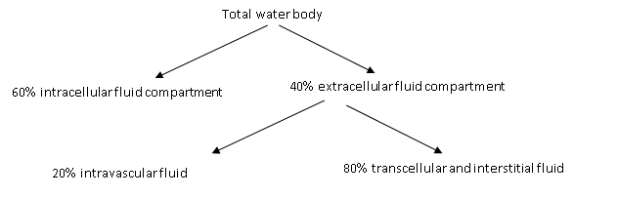

The intracellular and extracellular components comprise of water contained inside and outside the cells respectively. Intravascular fluid is the liquid component of blood and is present in the heart, arteries, veins, and capillaries. The interstitial and transcellular fluid includes fluids bathing all cells as well as cerebro-spinal fluid, the synovial fluid that lubricates joints, various secretions (saliva, bile, mucus, gastric juice and lymph).

**ii.) How is dynamism in water distribution in the body achieved?**

The fluids in the different compartments of the body do not exist in isolation but rather in compartmentalization, so there is constant exchange or dynamism of the fluids from one compartment to another. This is brought about by a number of factors.

**Factors or solutes influencing distribution of water in the body.**

Solutes are substances that can dissolve in a solvent to make a solution. The solutes that govern changes in the body fluids include;

* **Electrolytes**: These are molecules that dissociate into charged ions when in solution. Ions can be positively charged (cations e.g. sodium, potassium, magnesium and calcium ions) or negatively charged (anions e.g. chloride, phosphate, sulphate, and carbonate ions). In intracellular fluid, potassium and phosphate ions are the most abundant and in extracellular fluid, sodium and chloride ions are most abundant. Within each compartment, the concentration of cations should be equal to that of anions in order to have an electrically neutral solution i.e. homeostatic state in the body. Body fluids therefore differ in electrolyte content and concentration according to location and function.
* **Non**-electrolytes: Are organic compounds e.g. glucose and urea that move readily across the capillary membrane and work as in electrolytes.
* **Plasma proteins**: These are large and are retained in the capillaries. They tend to draw water to themselves creating colloidal osmotic pressure, which tends to retain water in the capillaries and prevents its transfer to the interstitial spaces.

**Forces that bring about dynamism**

Various forces act to maintain the equilibrium of fluids and body chemicals in all the compartments depending on the content of the different fluids. Such forces include;  
**osmosis**: This occurs when a semi-permeable or selectively permeable membranes (e.g. cell membranes) separates fluids of different solute concentration. This will result into water or fluid moving through the membrane from the side with less salute concentration to the side of high solute concentration in a bid to attain concentration equilibrium.

**Diffusion**: This involves movement of particles of matter (solutes) from high concentration to low concentration through a permeable membrane.

**Hydrostatic or filtration pressure**: The greatest part of fluid exchange in the body takes place through the capillaries whose thin walls allow small solute particles including water to pass through by the hydrostatic and filtration and filtration pressures exerted by the beating heart.

**b)i). Define essential fatty acids & give their role in human body**

Essential fatty acids (EFA) are fatty acids that cannot be manufactured by the body and so must be taken in the diet regularly, as their lack results in specific deficiency symptoms. Examples includes linoleic, linolenic and arachidonic acids, although linoleic acid is considered to be the only truly essential fatty acid since others can be synthesized from it. They can be got from vegetable oils, fish and poultry.

EFA are essential for growth; they play a role in regulation of cholesterol metabolism acting to lower blood cholesterol level; As a component of Phospholipids, EFA constitute an important part of all cell membranes and therefore maintain the integrity and functioning of cellular membranes.

Linoleic acid prevents and cures dermatitis in infants and can be converted to arachidonic acid essential in formation of prostaglandins. The prostaglandins are important in stimulation of simulation of smooth muscle contraction, lowering of blood pressure and are used therapeutically to induce uterine contractions and abortion.EFA are needed for a healthy skin, liver and kidney maintenances as well as resistance to diseases.

ii) How is **dynamism** in water distribution in the body achieved? (6 marks)

The fluids in the different compartments of the body do not exist in isolation but rather in compartmentalization, so there is constant exchange or dynamism of the fluids from one compartment to another. This is brought about by a number of factors.

**Factors or solutes influencing distribution of water in the body.**

Solutes are substances that can dissolve in a solvent to make a solution. The solutes that govern changes in the body fluids include;

* **Electrolytes**: These are molecules that dissociate into charged ions when in solution. Ions can be positively charged (cations e.g. sodium, potassium, magnesium and calcium ions) or negatively charged (anions e.g. chloride, phosphate, sulphate, and carbonate ions). In intracellular fluid, potassium and phosphate ions are the most abundant and in extracellular fluid, sodium and chloride ions are most abundant. Within each compartment, the concentration of cations should be equal to that of anions in order to have an electrically neutral solution i.e. homeostatic state in the body. Body fluids therefore differ in electrolyte content and concentration according to location and function.
* **Non**-electrolytes: Are organic compounds e.g. glucose and urea that move readily across the capillary membrane and work as in electrolytes.
* **Plasma proteins**: These are large and are retained in the capillaries. They tend to draw water to themselves creating colloidal osmotic pressure, which tends to retain water in the capillaries and prevents its transfer to the interstitial spaces.

b) (i) Define **essential fatty acids** and give their role in the human body (5 marks)

Various forces act to maintain the equilibrium of fluids and body chemicals in all the compartments depending on the content of the different fluids. Such forces include;  
**osmosis**: This occurs when a semi-permeable or selectively permeable membranes (e.g. cell membranes) separates fluids of different solute concentration. This will result into water or fluid moving through the membrane from the side with less salute concentration to the side of high solute concentration in a bid to attain concentration equilibrium.

**Diffusion**: This involves movement of particles of matter (solutes) from high concentration to low concentration through a permeable membrane.

**Hydrostatic or filtration pressure**: The greatest part of fluid exchange in the body takes place through the capillaries whose thin walls allow small solute particles including water to pass through by the hydrostatic and filtration and filtration pressures exerted by the beating heart.

**b).i). Define essential fatty acids & give their role in human body**

Essential fatty acids (EFA) are fatty acids that cannot be manufactured by the body and so must be taken in the diet regularly, as their lack results in specific deficiency symptoms. Examples includes linoleic, linolenic and arachidonic acids, although linoleic acid is considered to be the only truly essential fatty acid since others can be synthesized from it. They can be got from vegetable oils, fish and poultry.

EFA are essential for growth; they play a role in regulation of cholesterol metabolism acting to lower blood cholesterol level; As a component of Phospholipids, EFA constitute an important part of all cell membranes and therefore maintain the integrity and functioning of cellular membranes.

Linoleic acid prevents and cures dermatitis in infants and can be converted to arachidonic acid essential in formation of prostaglandins. The prostaglandins are important in stimulation of simulation of smooth muscle contraction, lowering of blood pressure and are used therapeutically to induce uterine contractions and abortion.EFA are needed for a healthy skin, liver and kidney maintenances as well as resistance to diseases.

ii) What is the **fate** of a glucose molecule in the cytoplasm of a cell? (4 marks)

In the cytoplasm, the glucose is split up to produce two 3-column molecules called pyruvic acid (pryuvate) by a process called glycolysis. This occurs as follows;

The glucose is first phosphorylated whereby a phosphate group is added to it hence required energy in form of ATP.

The phosphorylated glucose is then split up into 2 molecules of 3-carbon sugars each of which is subsequently converted to pyruvic acid.

In the presence of oxygen, the pyruvic acid enters the mitochondria and is converted to acetyl coA while in absence of oxygen, it is converted to lactic acid.

c) Outline the **sources and roles** of vitamin A in the human body (5 marks)

Active vitamin A is found almost exclusively in foods of animal origin (halibut liver oil, cod liver oil, liver, butter, margarine, cheese, eggs, herrings, milk).

Most carotenes come from vegetable sources (carrots, spinach, watercress, dried apricots, tomatoes, prunes, cabbage, peas, lettuce). Carotenes give carrots their characteristic color and are mostly found in leaves of young plants where their colour is masked by the dark green chlorophyll;

* Important in vision, general health of the eyes and a component of rhodopsin (visual purple) for dim light.
* Responsible for maintenance of the epithelilal membranes e.g. skin, digestive tract, reproductive tract, etc.
* Responsible for growth in children since it is necessary in development of bones and teeth.
* Important in protein synthesis and plays a role in electron transport system.
* Needed in the maintenance of adrenal cortex cells especially those which produce the hormone cortisol required in glycogen synthesis.
* It is necessary in the synthesis of thyroid hormones

**SECTION B**

4(a) Discuss the **processing and effect** on milk by the processes indicated

i) Pasteurization and sterilization (7 marks)

Pasteurization

* The milk is heated to over 720C for at least 15 seconds, and then cooled rapidly to below 100C.( flash process)

OR

The milk is heated to 63- 650C for half an hour and then cooled rapidly as above. ( Holder method).

Effect on milk

* Up to 10% of thiamin and vit B12 is lost.
* 25% of vitamin C is lost.

Sterilization

* In a batch process, where the milk is heated in bottles in an autoclave at up 1130C for 15-40 minutes.
* In continuous process, where the bottles pass on a convey or belt through hot water tanks, into a steam chamber ( under process) at 1130C for 15-40 minutes, then into cooling tanks.

Effects

* Alters the flavor of milk slightly
* Taste is altered
* Large amounts of vit B and C are destroyed.
* Milk becomes less digestible but it keeps longer.

ii) Spray drying and roller drying (7 marks)

Spray drying

The milk is sprayed through a very fine jet into a chamber in which hot air is circulating is quickly evaporated and the dried milk, fall to the bottom as a powder.

Roller drying

* Milk is run over heated revolving rollers and scraped off as it dries. The film of milk is cooled rapidly, then ground into a powder and sitted.

Effects

* Moisture reduced almost completely
* Reduced amounts of Vit B and C
* Most dried milk is skimmed, so reduced fat content.
* Flavoured is not as bland and neutral as that of fresh milk.

b) How would you ensure quality production of milk to reduce contamination? (5 marks)

) - Milk should be kept cool ( refrigerator)

* Leave milk bottles sealed or covered.
* Treat the animal for any diseases
* Don't store near strong smelling foods
* Inspection of the herd
* Cows must be kept clean
* The milk cans should be washed and dried before milking
* Check the fore milk bottles standing in sunlight.
* Never add fresh milk to state milk.

c) Outline the rules for preparing left over foods (3 marks)

- Food must be reheated and not re- cooked

* Food should be heated as a quickly as possible
* Food to be reheated should be used as soon as possible
* Food must be finely divided for quick penetration of heat.
* All ingredients must be cooked before mixing
* Extra- moisture should be added to rechauffe dishes
* Try to make re-heated dishes as attractive as possible
* Provide fresh veg's/ fruits to supply Vit C, colour and texture

d) Account for the increasing **popularity** in use of convenience foods today. (3 marks)

- Less leisure time being spent on food preparation.

- More women going out to work and so having less time to prepare food.

- Advances in food technology

- Increased freezer ownership

- Influence of advertising on peoples food habits.

5(a) i) Describe how **margarine** is manufactured (6 marks)

- Extraction; the seeds and nuts are cleaned, crushed and heated slightly to remove the oil. Solvents may be used to assist extraction.

* Referring; caustic soda is used to neutralize the crude oil. Its then bleached and filtered. Steams is passed through it to remove strong flavours
* Hydrogenation; hydrogen gas is forced through the unsaturated oils in the presence of nickel catalyst.This transforms the unsaturated fatty acids thus hardening the oils.
* Blending the oils- cultured skimmed milk, salt,colouring,vitamin A and D and any other additive such as emulsifiers are mixed together and then fed into a votator machine, which has the effect of churning and cooling the margarine until it begins to crystallize and solidify.
* Packing-the margarine is weighed, wrapped and packed automatically.

ii) List **four** different types of margarine, stating the purposes for which each is used (4 marks)

1. Table margarine-its general all purpose margarine.
2. Soft margarine (blueband,prestige):They are well aerated &spread easily –even when straight from a refrigerator. Purpose bread spread.
3. Slimming spreads (outline) have a high content of water.
4. High polyunsaturated margarines (fbra) contains a greater proportion of polyunsaturated fats than other margarines.

Purpose – more benefical to the body than other margarines since it provides poly unsaturated fats (essential fatty acids)

1. Cake margarine – developed to have a gd creaming properties.Some butter may be included. Purpose for making cakes ie easy creaming.
2. Pastry margarine: containing a high percentage of hydrogenated oils or animals fats to give it +ve very hard, plastic texture which is Ideal for pastry making especially for puff pastry.
3. High ratio margarines (super glyceminated fats):They are blended with an emulsifier so that they can be used with abnormally high ratios of sugar & water to produce satisfactory cakes.

b) i) What points must be observed when preparing and cooking vegetables in order to achieve maximum vitamin retention? (7 marks)

) Food shd be cooked quickly

* Avoid peeling vegetables
* Avoid exposure of vit c foods to air as oxidation will occur
* Avoid the use of Bicarbonate of soda
* Use little amounts of water
* Always blanch the vegetables
* Avoid oaking vegs
* Chop vegs with a sharp knife
* Use unbrushed vegs

c) Account for the following

i**) Structure and food value of wheat grain**  (6 marks)

The germ-At this point at which it is attached to the stalk, is the germ which constitutes 2% of the grain.

This is the embryo and is rich in proteins, fats, B-vitamins, vitamin E and Iron

The endosperm-which makes up over 80-85% of the grain. It is a food reserve on which the young plant lives until it develops a root system.

The brain (tough outer skin) 13% it consists of a double layer which protects the grain/developing embryo and it also controls the intake of water by the seed.

It is mainly fibre (cellulose) with some minerals and B-vitamins.

ii**) Uses of sugar in cookery**  (2 marks)

* As a valuable source of energy
* As sweetening agent for drinks, fruits
* As a preservative in jam, marmalade
* For improving the keeping qualities of some frozen goods.
* For a lightening effect in cake making
* For decorative finishes eg cake icing.
* A useful "dry store “which will keep in good condition for several years.

6(a) Discuss the **principles** of food preservation (4 marks)

* To inhibit the action of enzymes which cause decay in food
* To destroy the micr0-organisms which decay food and to remove conditions which allow the growth of such micro-organisms.
* To keep he colour, flavour, appearance and nutritive value of the food as near as possible to the original unprocessed food.
* To prevent oxidation and recontamination of the preserved food by sealing it quickly and completely.

b) Giving reasons, Outline the basic **steps** you would follow to ensure a good Meat stew. (5 marks)

**Method**

* Melt the lard/vegetable fat on a large pan and fry the meat lightly until brown .Make oil hot enough to seal the extraction & quickly brown the meat.
* Remove the meat and add the onions, fry these until they are just beginning to change colour. To prevent burning them try the onion easily & quickly.
* Remove the onions and add the flour. Prevent burning of the onions to make a roux
* Cook the flour gently to prevent burning & over cooking of flour until it turns brown to prevent burning of the onions
* Carefully add the stock; stirring all the time to prevent wimps & burning of source bring this to the boil.
* Add the meat and onions to the pan, season and allow to simmer for 1 hour.To cook the meat & starting to cook immediately
* After this time, add the vegetables and cook for another 30 minutes.To prevent over cooking of the vegs.
* Serve by piling the meat in the centre of an oval dish and arranging the vegetables round it. Serving it altractively.

c) Examine the following;

i) The uses of **gelatine** in food preparation. (5 marks)

* Jellies
* Whips,sponges
* Soufflés
* Sweets
* Cream
* Aspic (used in setting meat & fish dishes),
* Ice cream
* Thickening agente.g in soups-stabilizer e.g in
* Crystallized fruits e.g cherries
* In medicines
* Yoghurt.

ii) Effects of **food colour** in the diet (4 marks)

* To reinforce colours already present in food
* Ensure uniformity of colour in food from batch to batch
* Restore the original appearance of food whose colour has been affected by processing
* Give colour to certain foods

d (i) What problems are you likely to encounter when planning meals for strict

Vegetarians. (7 marks)

* Lack of nutrients in their diet.
* Difficulty to meet Iron requirements, it B,2 requirements and protein.
* Difficult to stimulate the flow of digestive juices because of lack of flavour.
* Meals are too bulky due to many vegs.
* Meals are too monotonous since they are restricted
* Too expensive
* Digestion may be difficult because of much cellulose
* Extra time is required to prepare the meals
* Some times the foods are out of season.
* The meal lacks fat soluble vitamins which are usually got from animal foods.

**END**